Beauty store

Web programming class project 2022/2023

|  |  |  |  |  |
| --- | --- | --- | --- | --- |
| Student Name in English | Student Name in Arabic | Student ID | Section | Work percentage |
| Roaa sabbarini | رؤى باهر صباريني | 11924302 | #1 | 50% |
| Aya kanaan | ايه محمود كنعان | 11941044 | #1 | 50% |
|  |  |  |  |  |

Date/time

---------------------------------------------This section is intended for the Instructor---------------------------------------

|  |  |
| --- | --- |
| **Topic** | **Mark** |
| Project Idea |  |
| Project Complexity |  |
| Project Tools |  |
| Project Requirements and Modeling |  |
| Project Discussion |  |
| Project Completeness |  |
| Project Output Results or reporting |  |
| Project Administration and Management |  |
| Project Report |  |
| Team work |  |
|  |  |

**Tabel Of Content**

* **Abstract.**
* **Introduction**
* **Requirements**
* **Tools used in the project**
* **Project database EER or UML**
* **discussion about your project GUI work, what each interface do**
* **Conclusion**
* **References**

**Summary**

**Here, we decided to create a website to sell beauty products, which is beauty**

**A store selling cosmetic products of all kinds, for eyes, lips, face, perfumes.**

**We decided that the design should be:**

**Home , About , Sale , Gallery , Contact Us.**

**an introduction**

**The idea of this site is to create an online store that facilitates the purchase process, as it saves time and effort in purchasing products from the market**

**In our store, we choose good brands and original and guaranteed products**

**Requirements**

**Beauty requirements:**

**The beauty app will be used by customers (users).**

**⦁ This website is divided into sections, each section is visible by the user.**

**We have a Home section here as the main interface of the site, then an About section here, a little bit about our store, and then sale section offers here we present all available offers and discounts on products , and then the gallery section here is the products that are offered to customers at the price of each product , each product divided by the type of each.**

**Then the contact us section.**

**⦁ Each user can create an account on the site, he can view the site with his account**

**Every user can purchase from our store**

**Each user has: first name, last name, phone number, city, e-mail and password**.

**Tools used in the project**

* **Visual Studio Code**



* **Phpstorm**



* **XAMP**



**Project database EER or UML**

**UML**

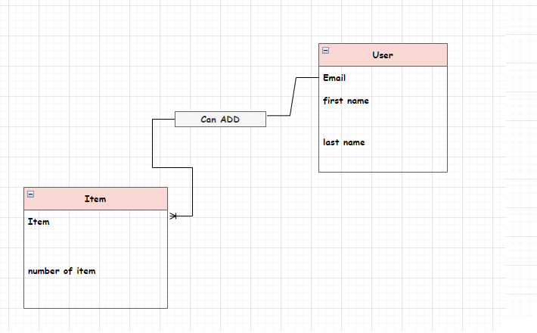

**EER**

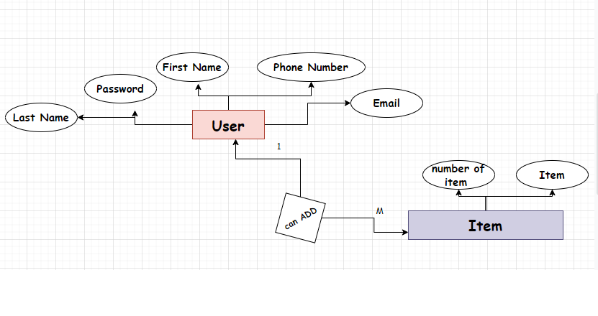

**discussion about your project GUI work, what each interface do**

**In the beginning , the page loads before entering the initial page:**

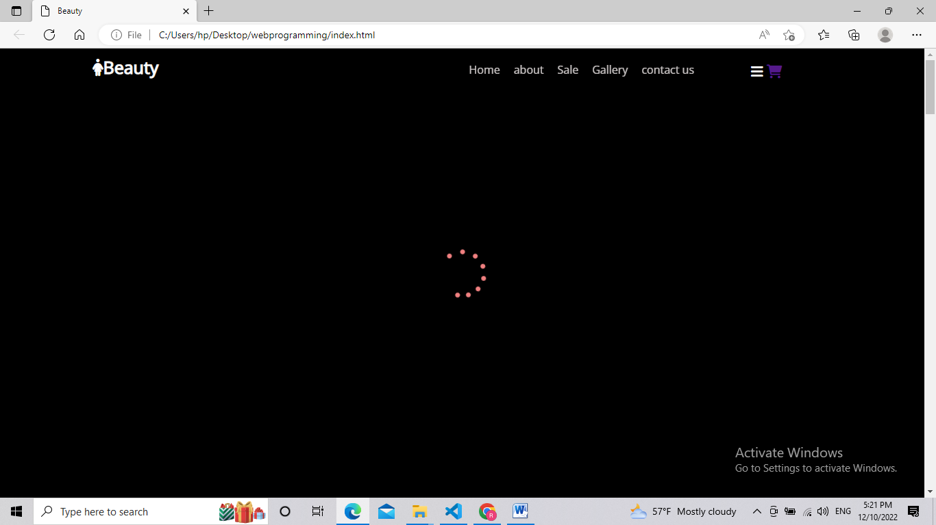

**Login page and sign up page:**

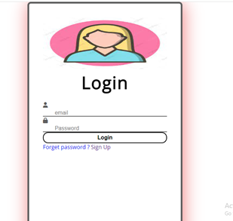

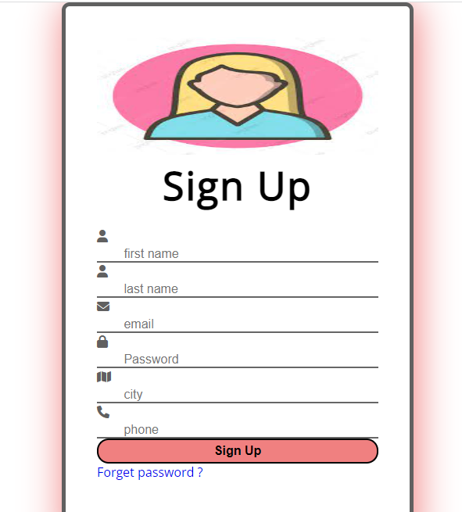

**Home page**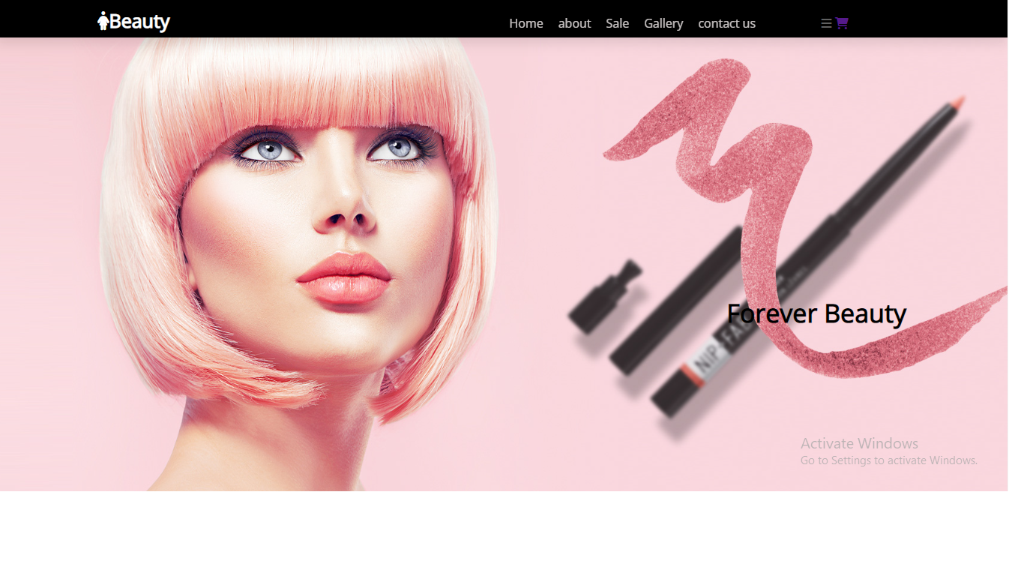

**About us page:**

**This page is in the home page we can access it either by clicking on the about button in the top or by scrolling** 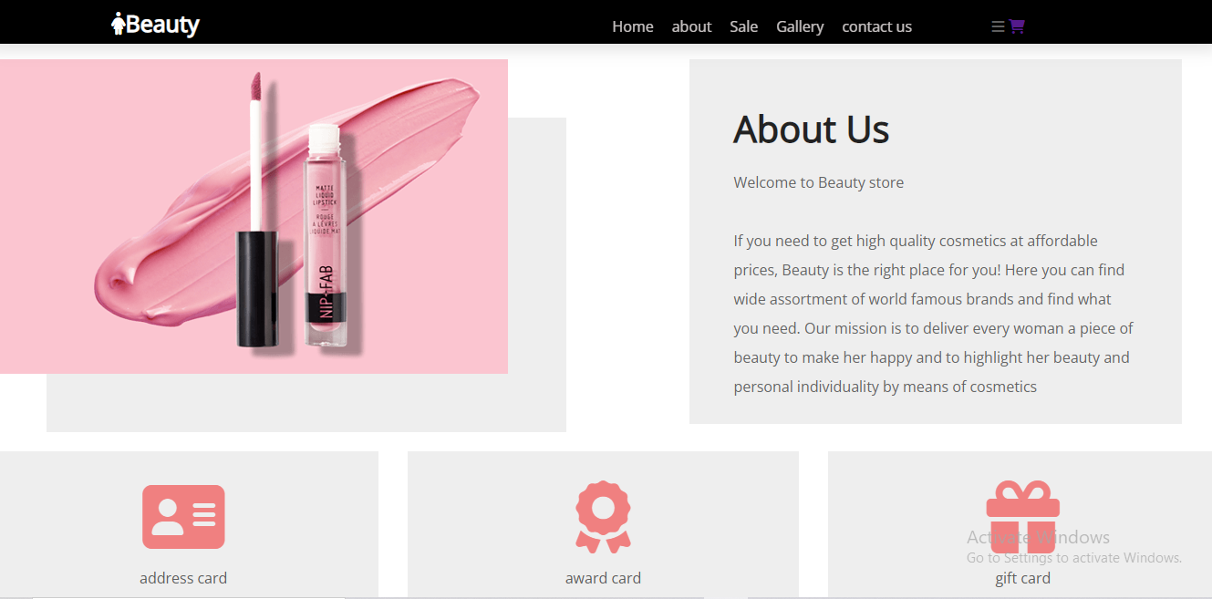

**Gallery page: This page is in the home page we can access it either by clicking on the Gallery button in the top or by scrolling** 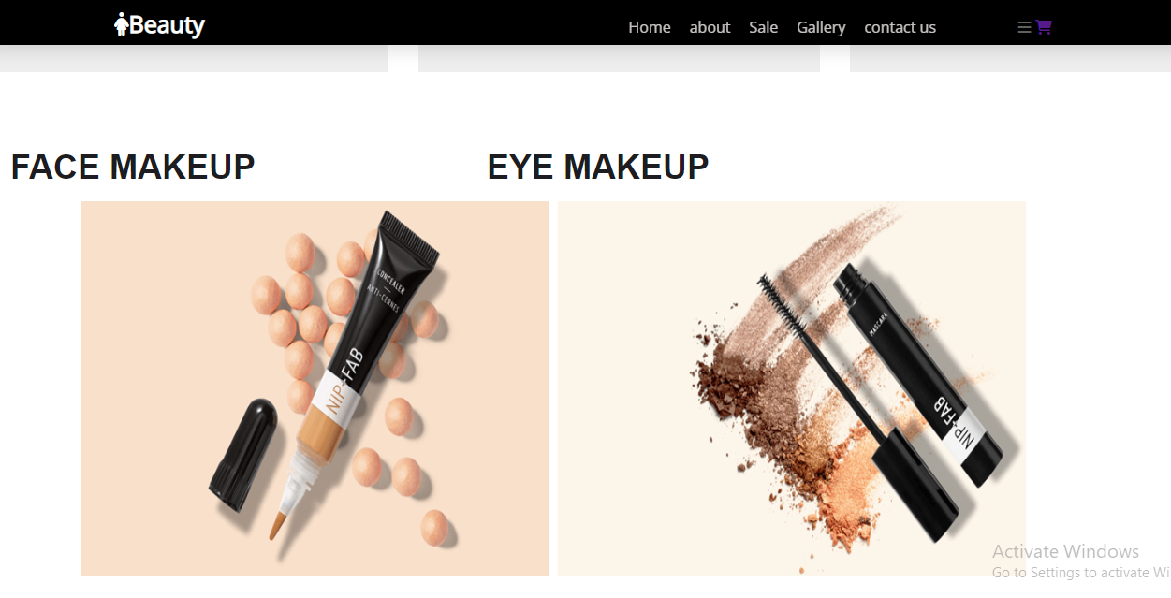

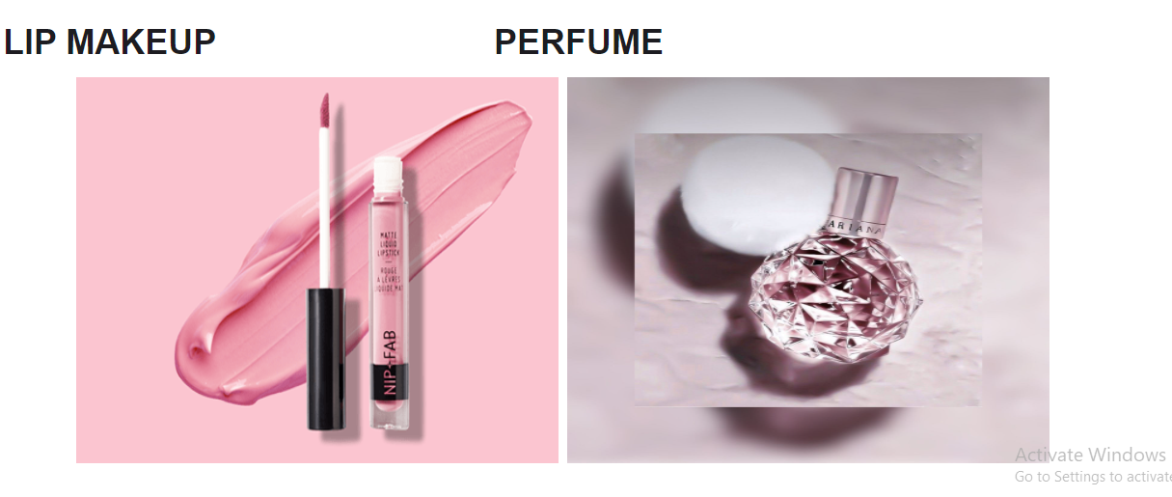

**Best seller in home page:**

**\*when we hover the mouse on button, the color of button change to pink, and when we hover the mouse on the item we note border surrounding the item**

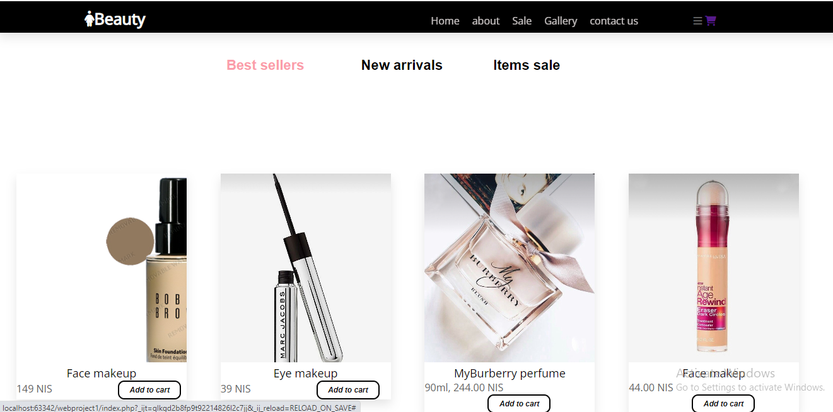

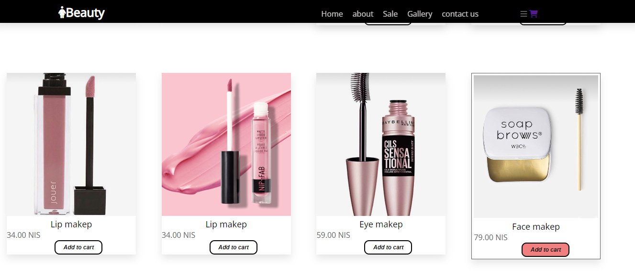

**Popular Brands:**

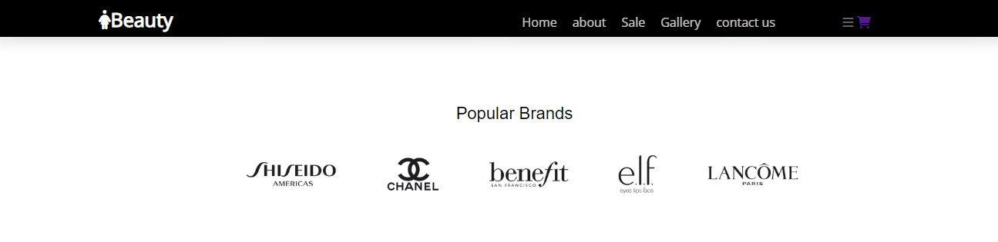

**Black Friday in home page:**

**This page is in the home page we can access it either by clicking on the Sale button in the top or by scrolling**

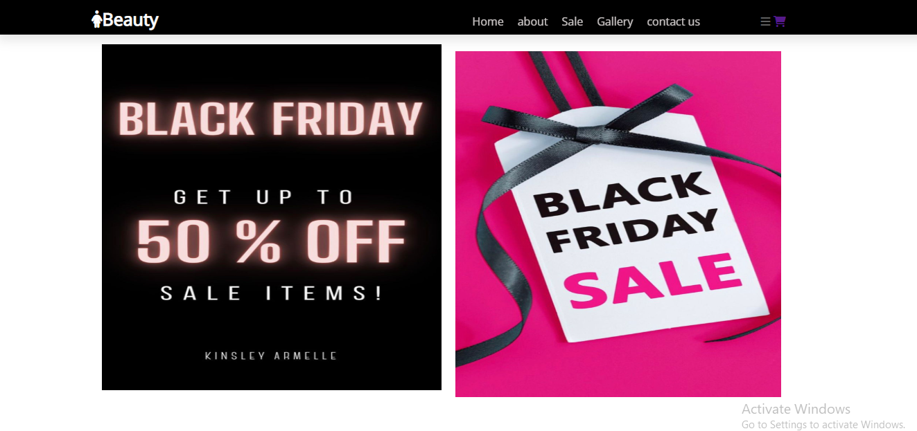

**Last section on home page:**

**This page is in the home page we can access it either by clicking on the contact us button in the top or by scrolling**

**\*when we hover the mouse on social networking site, the color change to pink**

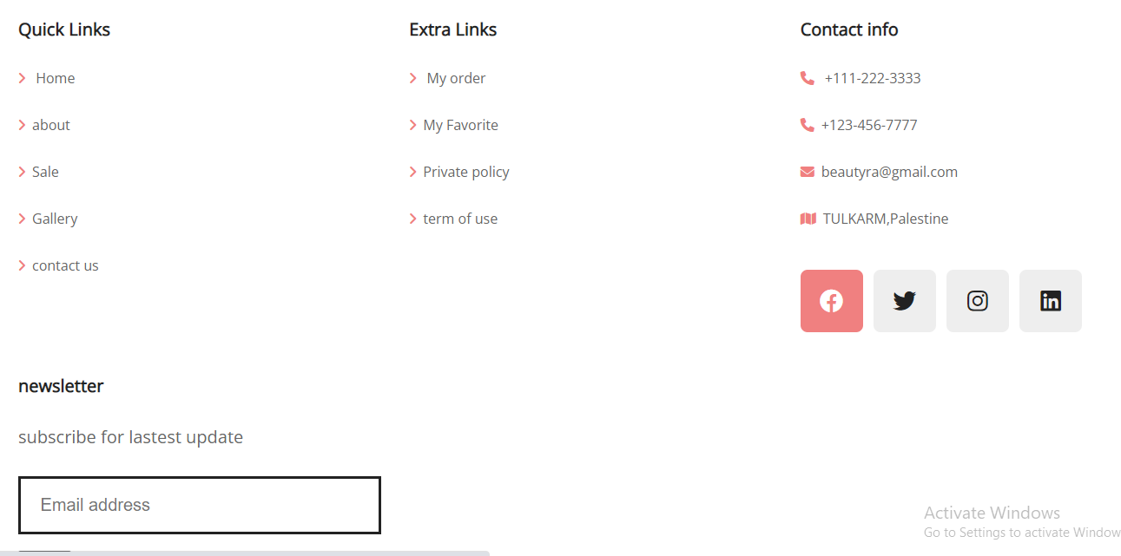

**When click on the face makeup**

**Shows all products related to facial beauty**

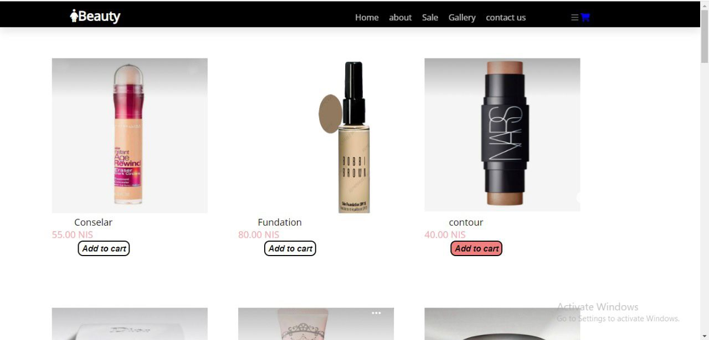

**When pointing on add to cart, the color of the button changes to red**

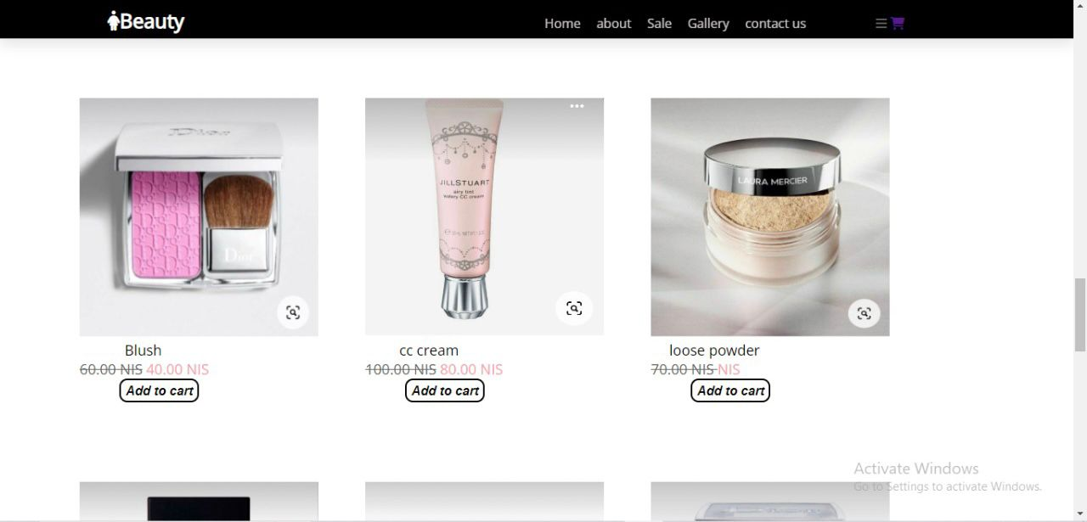

**When click on the eye makeup**

**Shows all products related to eye beauty**

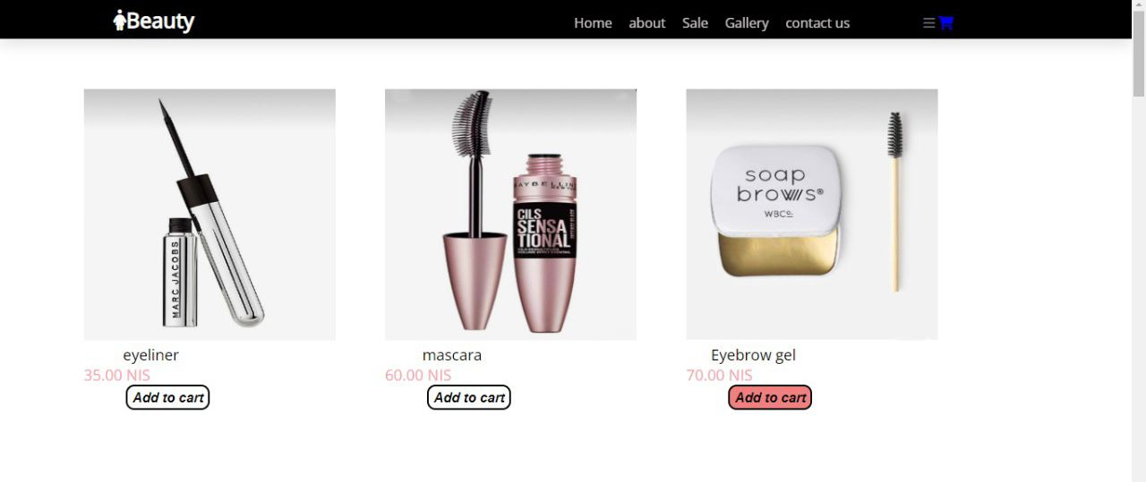

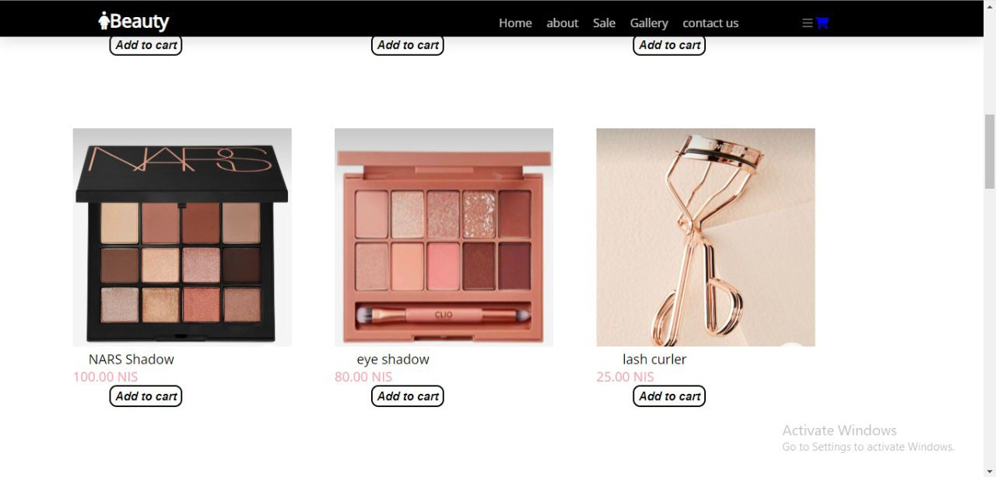

**When click on the lips makeup**

**Shows all products related to lips beauty**

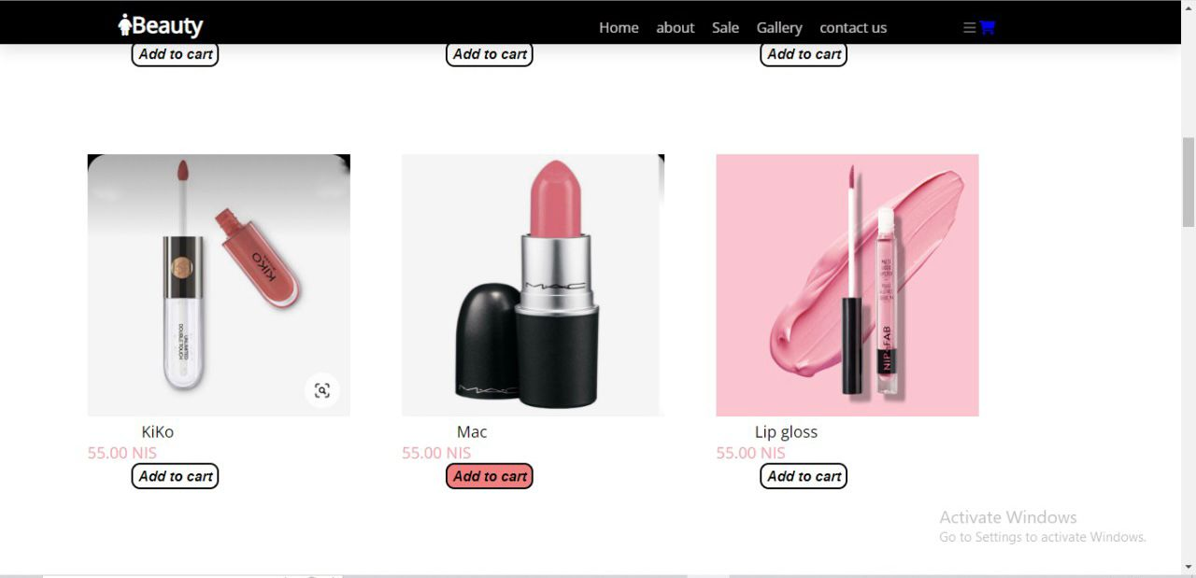

**When click on the Perfumes**

**Shows all products related perfumes**

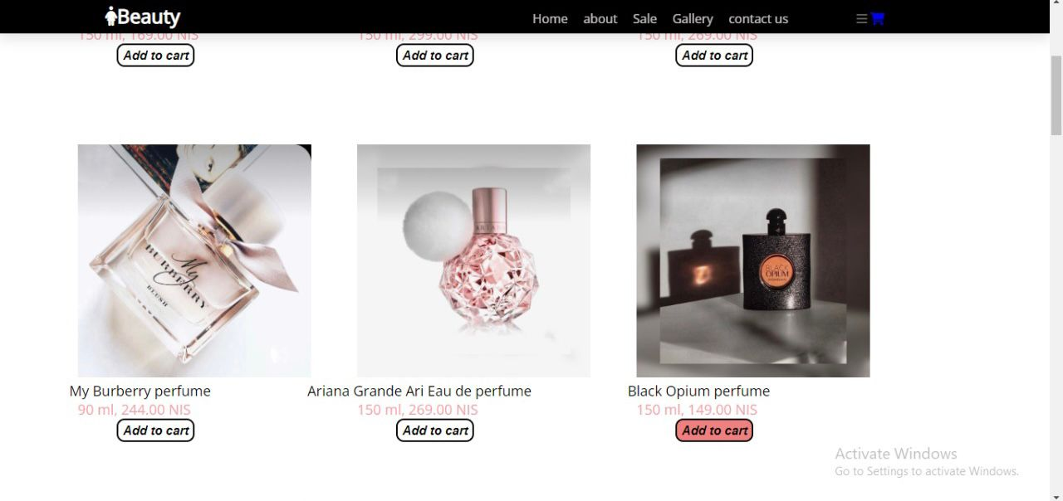

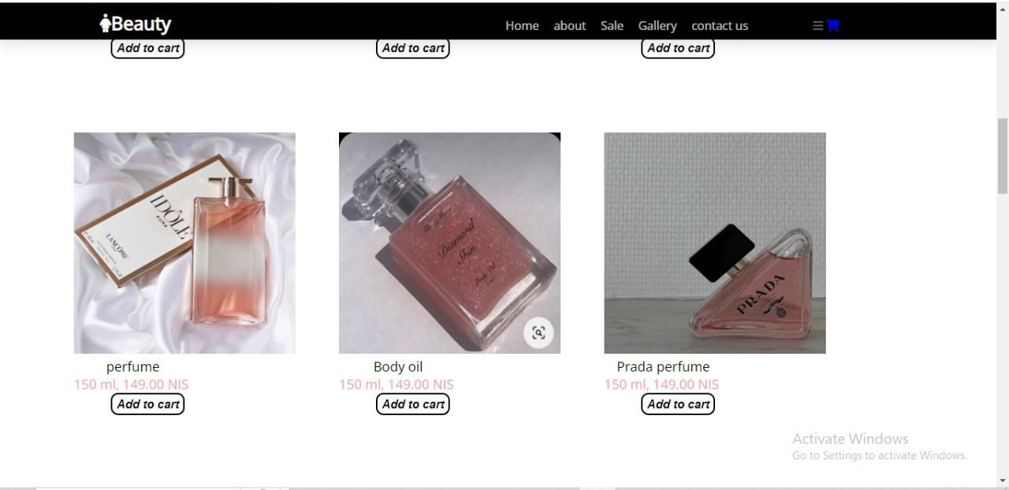

**When click on the Black Friday**

**Black Friday discounts appear for all products**

**Where the original price and the price after the discount appear**



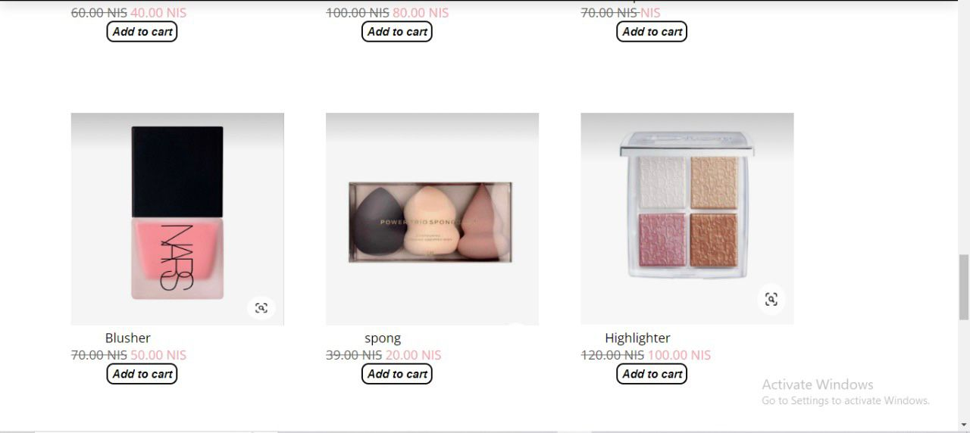

**NOTE:**

**There are many products in our project, but we have added some samples to the report**

**When the screen is minimized, the project view is adapted to the screen size**

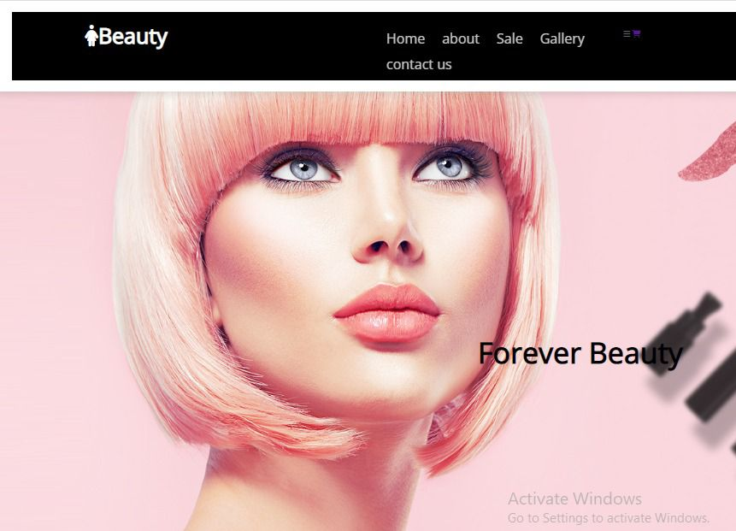

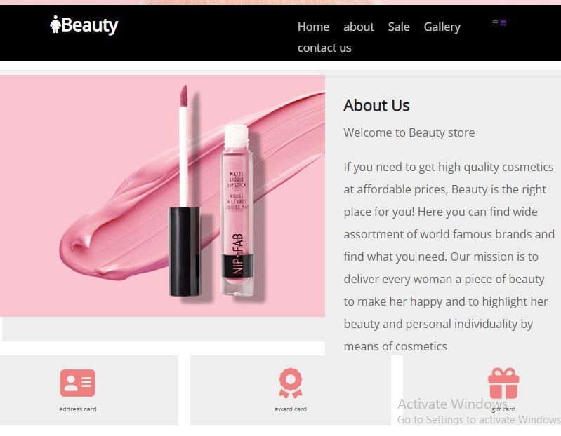

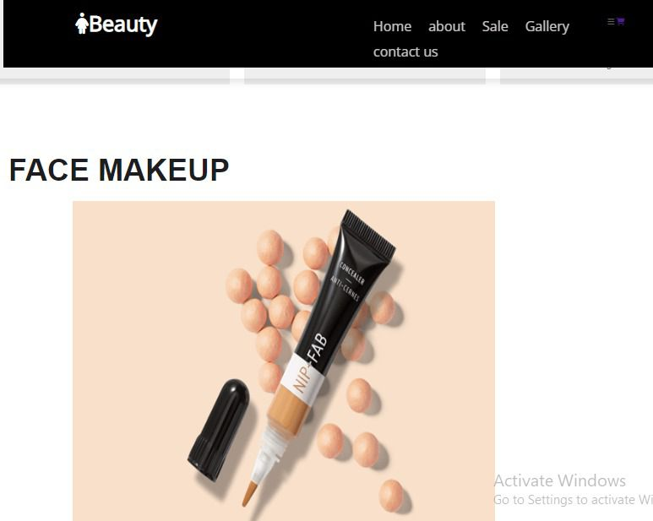

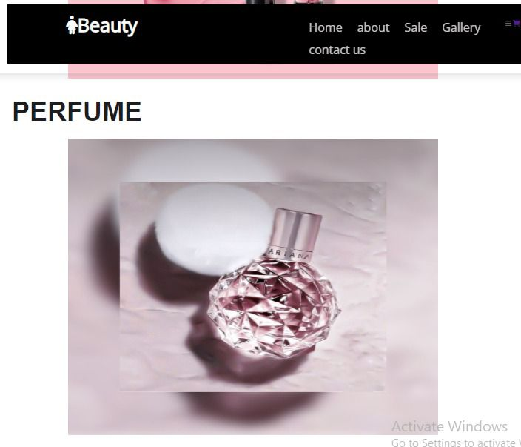

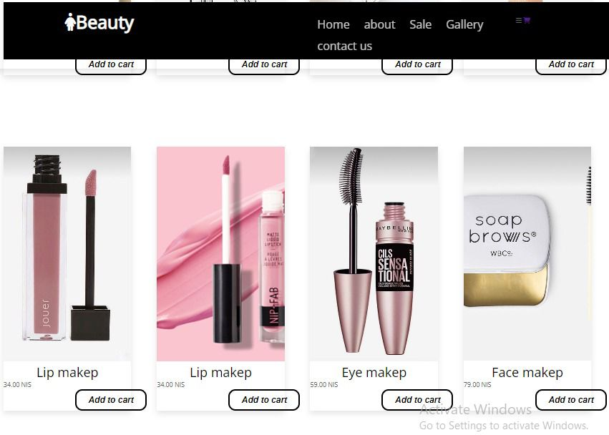



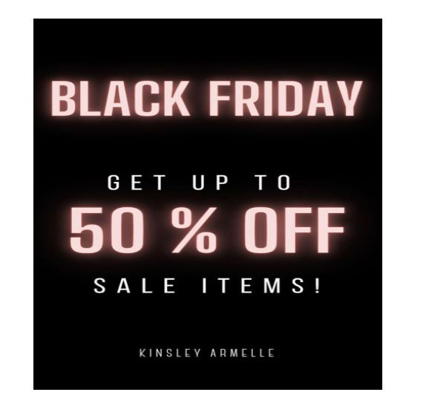

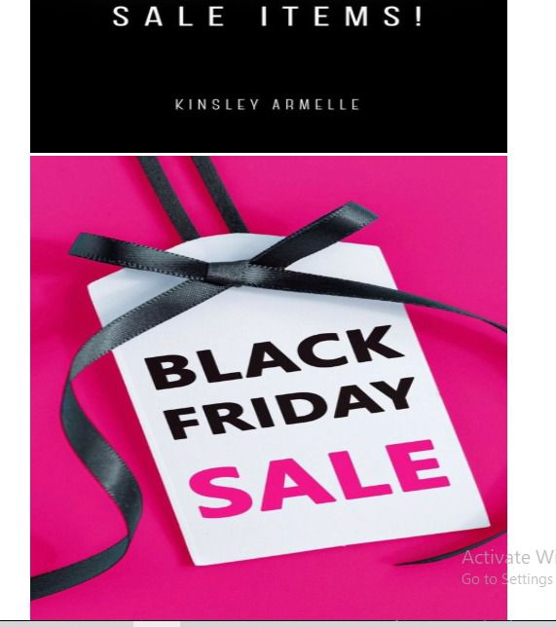

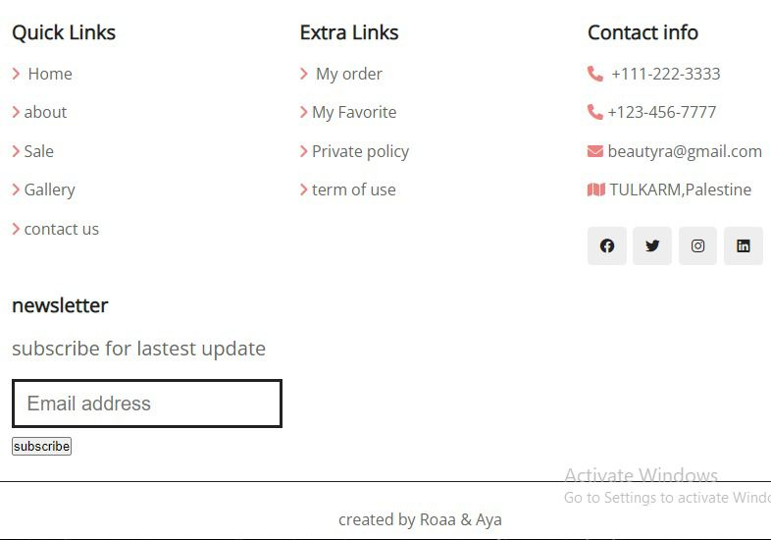

**When I click on cart I will find the product I add it and I determine the quantity of product**

